Nyon Install Guide
Whilst all reasonable care has been taken to ensure that the details are true and not misleading at the time of publication, no liability whatsoever is assumed by Automature LLC, or any supplier of Automature LLC, with respect to the accuracy or any use of the information provided herein.
Any license, delivery and support of software require entering into separate agreements with Automature LLC.
This document may contain confidential information and may not be modified or reproduced, in whole or in part, or transmitted in any form to any third party, without the written approval from Automature LLC.
Copyright © 2012 Automature LLC
All rights reserved.
Revision History
Ver. | Date | Name | Description of Changes
1.0 | 17/09/2012 | Dipayan Sengupta | First Edition
Contents
1 Introduction 4
1.1 Document Purpose 4
1.2 Intended Audience 4
1.3 References and Other Related Documents 4
2 Dependencies 5
2.1 Dependencies for Nyon Server: 5
3 Nyon Server Installation and Execution 6
3.1 Nyon installer download 6
3.2 Initialization of installation 6
3.3 Completion of installation 7
3.4 Architectural Workflow 8
3.5 Executing a Test plan from Zermatt 8
3.5.1 Uploading a test suite 9
3.5.2 Mapping testcases and topologysets 9
3.5.3 Test Plan Execution 10
4 Nyon Client Installation and Execution 11
4.1 Nyon installer download 11
4.2 Initialization of installation 11
4.3 Completion of installation 12
4.4 Architectural Workflow 12
4.5 Executing a Test plan by Nyon Client 13
4.5.1 Downloading a Test plan 13
4.5.2 Executing a test plan 13
4.5.3 Editing Davos Configuration 14

Introduction

Nyon is Automature's automated application and test deployment software. It leverages planning data that already exists in Automature's Planning and reporting tool Zermatt, and is able to copy, install, configure and execute applications that need to be tested. NYON works best in an environment where test cycles are typically run after each nightly build on multiple machine environments. By allowing kits and tests to be deployed and executed automatically, and concurrently, NYON helps with speeding up detection of obscure environment specific anomalies, and helps dramatically increase platform coverage effectiveness for regression testing.

1.1 Document Purpose

This document walks you step-by-step through installation of Nyon Server as well as Client. To get further information refer NYON Forum and the Help.txt that can be found in the installation directory.

1.2 Intended Audience

This Manual is intended for people who would be executing testsuites or testcases from Zermatt or execute test plans. It also assumes a good understanding of the development and target platform environments.

1.3 References and Other Related Documents

The following documents provide additional useful information about Automature's other products, and how they relate to Nyon.

1. Zermatt User Manual
2. Chur Programmer's Guide

Dependencies

Before running Nyon on a computer, it has to meet some basic requirements:
Operating System – Microsoft Windows XP or higher
Software – Java(TM) SE Runtime Environment 1.6

2.1 Dependencies for Nyon Server:

To run Nyon Server, the following Automature Products are needed to installed in the machine:
- Zug (5.2 or higher)
- Zuoz (4.7 or higher)
- Zermatt (3.0 or higher)

Nyon Server Installation and Execution

3.1 Nyon installer download

Download the Setup of the latest Nyon package from the Automature FTP site. Please contact sales@automature.com to the log in credentials to the FTP.

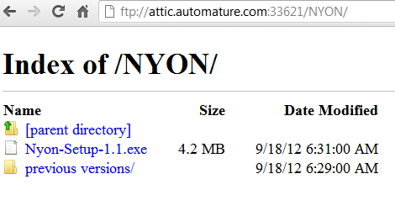

3.2 Initialization of installation

Nyon is a self-executable kit. Please choose Nyon Server and provide the location for installation.

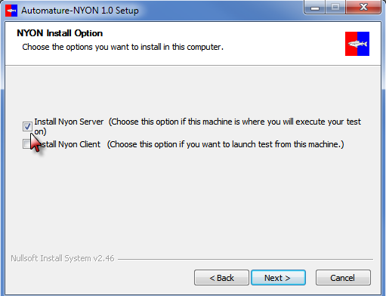

3.3 Completion of installation

To verify that Nyon Server was installed properly and also running, it should be listed as a Service.

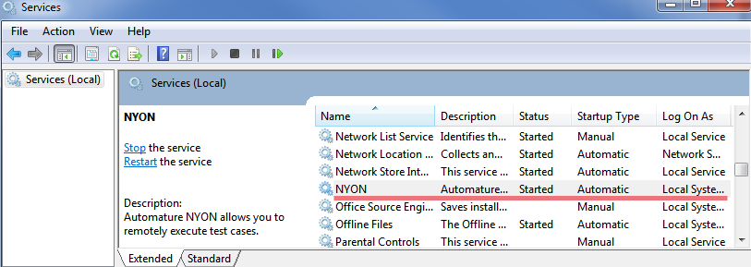

Please Note: Zug and Zuoz must also be installed in the same machine as well where Nyon Server is installed.

3.4 Architectural Workflow

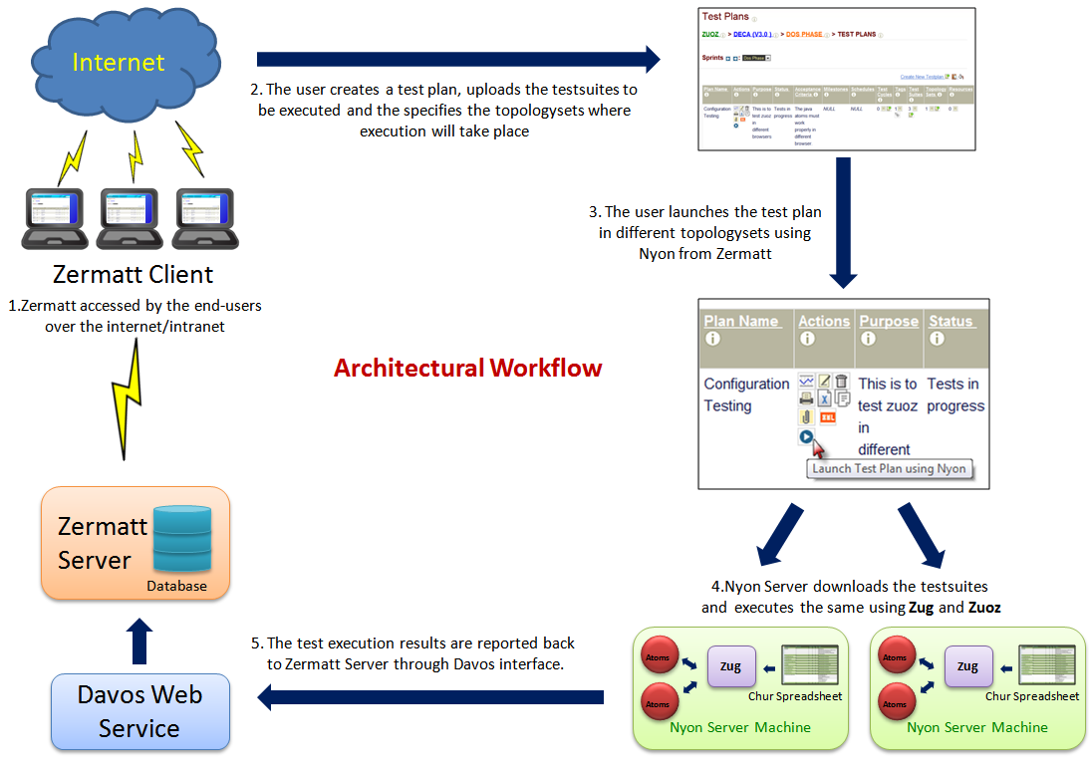

3.5 Executing a Test plan from Zermatt

The following is a snapshot of the Test Plan page in Zermatt:

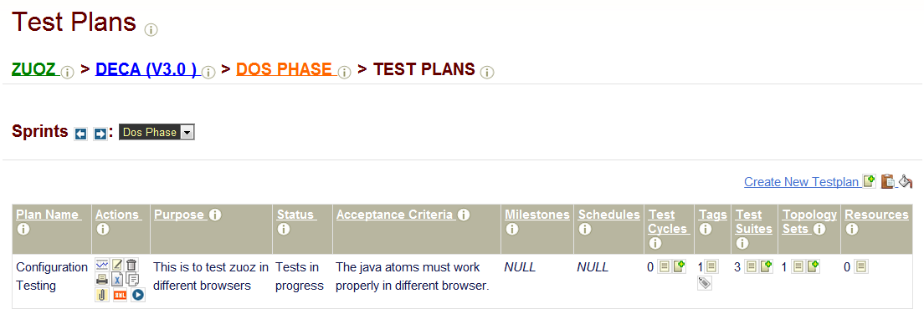

Each test plan must be mapped to at least one test suite and one topology set.

3.5.1 Uploading a test suite

The test suites must be listed in the TestSuites Page under a given Product. The user must upload the test suite spreadsheet which contains all the test cases to execute.

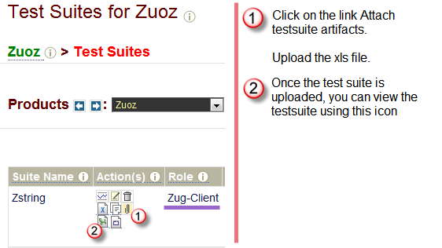
The user must specify the following in the Config sheet of the spreadsheet before uploading in Zermatt:
- Credentials for database connectivity
- Credentials for Davos connectivity
- Test suite Role which must match with the one you have stated in the TestSuites Page as well.
For more detailed information please refer to Chur Programmer's Guide

3.5.2 Mapping testcases and topologysets

After uploading the testsuites in the TestSuites Page, the user must map the testsuites as well as test cases to execute from the TestPlan Page**.

The following snapshot shows mapping of testsuites to a particular test plan.
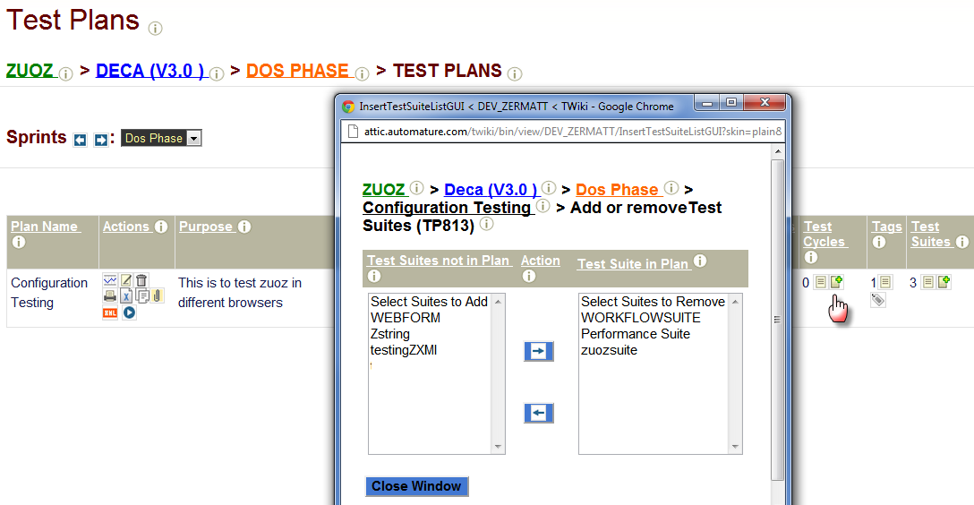

The following snapshots shows mapping of test cases in a testsuite which will be executed in that test plan.

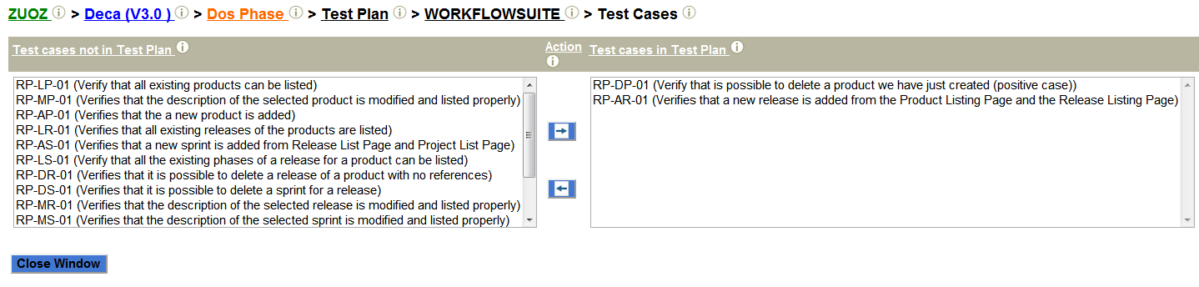

After mapping of testsuites, the user needs to map the topologysets as well**.
The topologyset must contain at least one topology with the role specified in the Chur sheet.

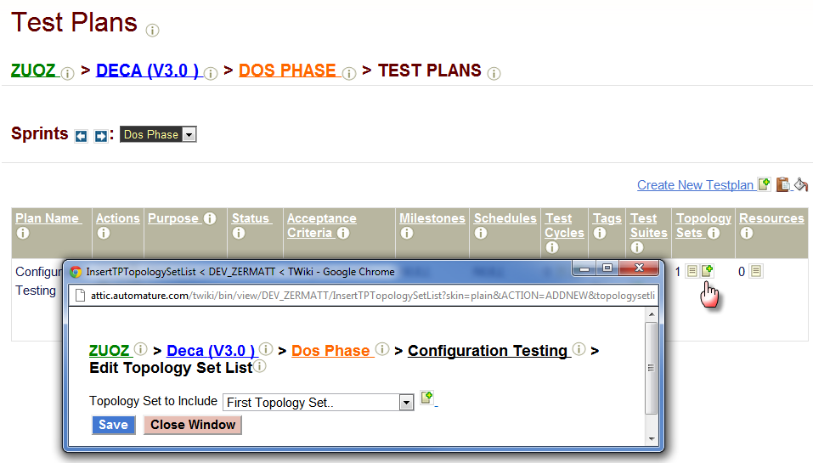

**For more detailed information please refer to Zermatt User Manual .

3.5.3 Test Plan Execution

To execute the test plan, Click on the icon under the Action Column in the Test plan page.
The test suites will be automatically executed in the said topologysets and the execution records will be reflected in the latest test cycle automatically created by Zug.

Multiple windows will pop up ( equal to the number of topologies where execution will take place) where the output of the test cases executed is shown.

Click on the icon under the Test Cycles column to navigate to the Test Cycles page.

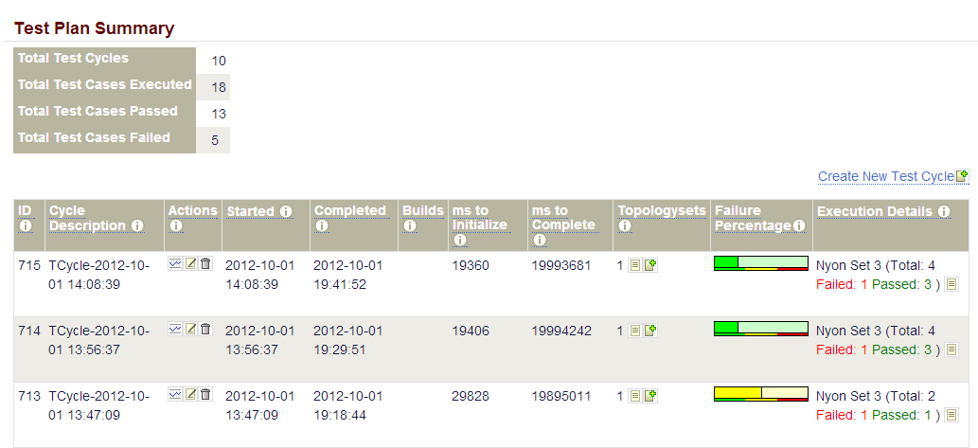

Nyon Client Installation and Execution

4.1 Nyon installer download

Download the Setup of the latest Nyon package from the Automature FTP site. Please contact sales@automature.com to the log in credentials to the FTP.

4.2 Initialization of installation

Nyon is a self-executable kit. Please choose Nyon Client and provide the location for installation.

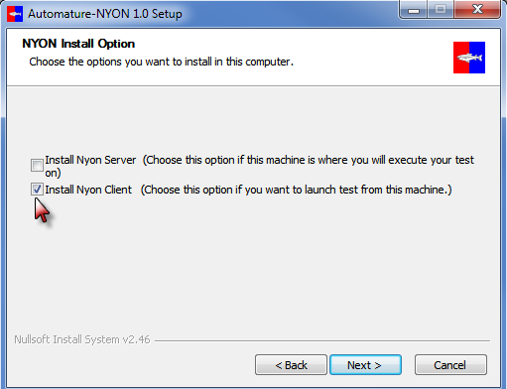

Please provide the credentials for Davos Configurations:
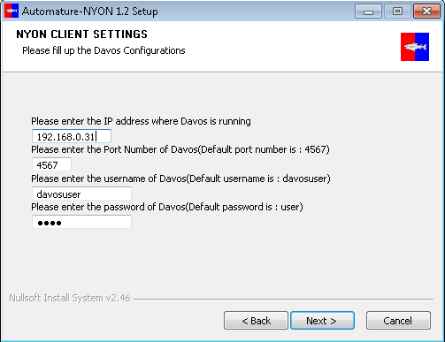

If you have any problem with the installation kindly contact us at support@automature.com.

4.3 Completion of installation

To verify that Nyon Client was installed properly and also running, it should be listed

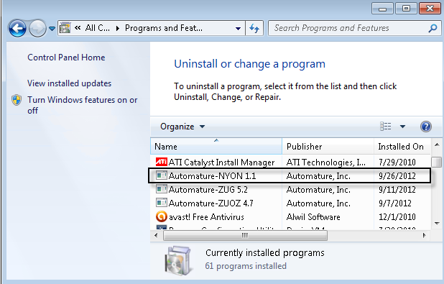

Please Note: Zug and Zuoz must also be installed in the same machine as well where Nyon Server is installed.

4.4 Architectural Workflow

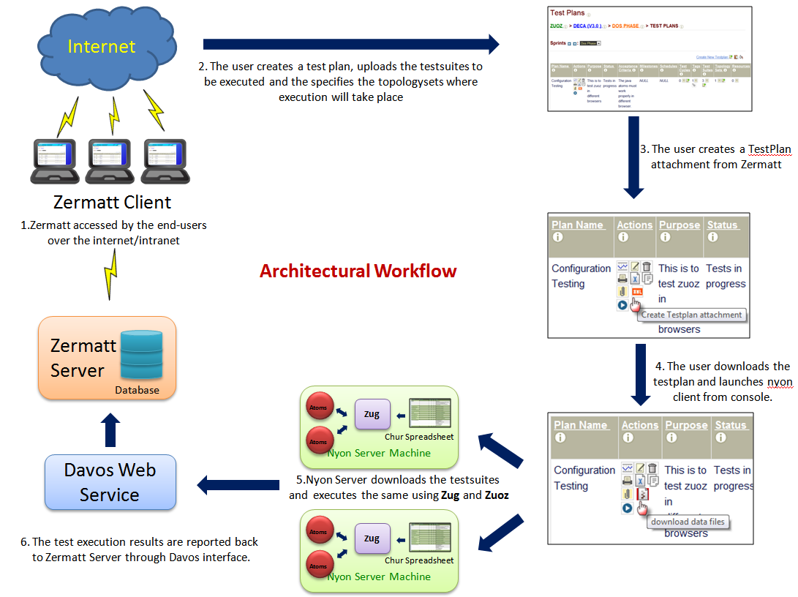

4.5 Executing a Test plan by Nyon Client

Please follow chapters 3.5.1 and 3.5.2 to upload test plan to map testsuites and topologysets.

4.5.1 Downloading a Test plan

Once the testsuites and topologysets are mapped to a test plan, click on the following link

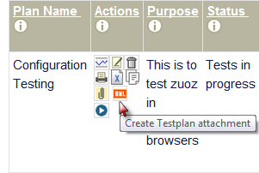

The icon automatically changes to and then download the test plan.

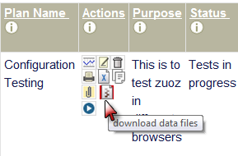

Example of a downloaded test plan is Testplan_924.txt.

4.5.2 Executing a test plan

Open the command prompt and type the following:

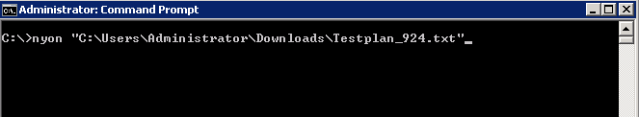

Nyon will automatically launch the test plan in the topologysets specified.

4.5.3 Editing Davos Configuration

To edit or make changes in the Davos configuration, navigate to Nyon-Client folder in the Nyon Installation Directory. Edit the NyonClientINI.xml file.

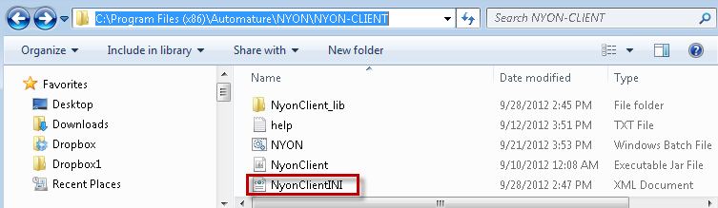

The following is a example of the xml file.

